**Center Name: ACE-HCMC-2-FPT.**

**Address: 590 Cach Mang Thang 8, District 3, Ho Chi Minh City, Viet Nam.**

**Blue Pumpkin**

**Design Document**

| **Supervisor:** | Mr.Tran Phuoc Sinh | |
| --- | --- | --- |
| **Semester:** | 3 | |
| **Batch No:** | T1.2110.A0 | |
| **Group No:** | 1 | |
| **Order:** | **Full name** | **Roll No.** |
| 1. | Phan Thanh Phuong | Student 1341583 |
| 2. | Tran Le Thien Phuc | Student 1344659 |
| 3. | Nguyen Tam Hieu | Student 1275244 |
| 4. | Nguyen Duc Anh | Student 1341590 |
| 5. | Vu Lam Minh Tuan | Student 1341524 |

**This is to certify that**

**Mr.**Phan Thanh Phuong

**Mr.** Nguyen Duc Anh

**Mr.** Tran Le Thien Phuc

**Mr.** Nguyen Tam Hieu

**Mr.** Vu Lam Minh Tuan

**have successfully designed & developed:**

eProject: ***Employee Management***

**Submitted by:**

Mr. Tran Phuoc Sinh

**Date of issue:** 10/02/2023

**Authorized Signature:**

**Mr.** Nguyen Tam Hieu

**TABLE OF CONTENTS**

**Review 1**

1. INTRODUCTION
2. PROBLEM DEFINITION
3. REQUIREMENT SPECIFICATION
4. SYSTEM REQUIREMENT

**Task sheet Review 1**

**Review 2**

1. ARCHITECTURE & DESIGN OF THE ePROJECT
2. ALGORITHMS – DATA FLOWCHART
3. USE CASE DIAGRAM
4. ENTITY – RELATIONSHIP DIAGRAMS

**Task sheet Review 2**

**Review 3**

* + - 1. Site Map
      2. GUI

**Task sheet Review 3**

# REVIEW 1

## I. Introduction

First and foremost, we would like to express the deepest appreciation to our admirable instructor – Mr. Tran Phuoc Sinh. During the time of the project, he continually and convincingly conveyed a spirit of adventure in regard to research and scholarship, and an excitement in regard to teaching. Without his guidance and persistent help this dissertation would not have been possible. Therefore, once again, we truly value your dedication and guidance.

Next, it would have been impossible to carry out and complete this project without the collaboration among our team members. Although we have gone through many obstacles during the project implementation, eventually we gained what we aimed at by our hard work, our strong commitment and of course, our brotherhood.

Finally, thanks to Aptech’s eProject team, we had a golden opportunity to apply what we have learnt into reality and gain hands-on experience which is essential for our future career.

## II. Problem Definition

Our client is a marketing agent of an internet marketing company, who provides different services like dial up services and the broadband services. They want a website for the interactive and entertainment purpose of the Employees.

Our client wants the application to perform the following tasks:

1. The portal will have the following logins
   1. Admin
   2. Employee
2. The admin will have the authority to create and delete the profile of an employee.
3. The employee profile once created, can login in to the site through the user name and the password provided.
4. On the home page of the website, the details of the upcoming events like meetings, games, competitions, etc. in the company will be displayed in brief.
5. To encourage the employees and to build a friendly rapport in the company they started conducting games and distributing the prizes.
6. The home page should also include the winners details of the events conducted recently.
7. The admin will have the right to accept the participation request based on the requirement.
8. Also the application should have a reminder, which will remind about the birthdays of the day. And this reminder should be active for all the user logins (admin, and employee)
9. Once the employee logins into the site, how will be able to send his request for the participation in any of the events.
10. He can also view the details of the events in detail.
11. The site should also contain the FAQ s like
    1. How to participate in the events?
    2. What if I am unable to login into the site?
    3. What if I am unable to send the participation request for the event?
    4. How can one be intimated with the upcoming events

There should be a contact and support page where the details of the people to be contacted, etc. to be displayed.

## III. Requirement Specification

Requirement Specification

1. For guest User:

* Visit the Home Page and can read all news about events of company
* User can read About Us and Contact Us in Home Page

1. For Admin:

* Admin can create, delete and update the profile of an employee
* Admin can create and provide account for employee
* Admin can create, delete and update events in page
* Admin will has the right to accept the participation request based on the requirement
* Admin can create FAQ, About Us
* Admin should be a contact and support page where the details of people to be contacted, etc. to be displayed.
* The application should have a reminder, which remind about the birthdays of the day. And this reminder should be active for all user logins

1. For Employee:

* The employee profile once created, can login in to the site through the user name and the password provided
* The employee is able to sent his request for the participation in any of the events
* The employee can read details of the upcoming events like meetings, games, competitions, etc.
* The application should have a reminder, which remind about the birthdays of the day. And this reminder should be active for all user logins.
* The employee can read the winners details of the events conducted recently in home page.

Non-functional Requirement Specifications

1. Good using Interface and Experience
2. Clean code
3. Try hard to improve the performance
4. Try this website to run on all browsers
5. Try limit bugs on this website

## IV. System Requirement

1. Hardware

* A minimum computer system that will help you access all the tools in the courses is a Pentium 166 or better
* 256 Megabytes of RAM or better
* Windows 2000 (or higher if possible)

1. Software

* Notepad/HTML editor/visual studio/J2EE
* Java/asp.net
* SQL Server 2000
* IE 5.0/ Netscape 6.0
* Visual studio.net

# Task Sheet Review 1

| **Project Ref. No.:**  **eP/Vehicle-Insurance- Management/04** | | **Project Title:** | **Activity Plan**  **Prepared**  **By:** | **Date of Preparation of Activity Plan:** | | | |
| --- | --- | --- | --- | --- | --- | --- | --- |
| **Sr. No.** | **Task** | **Actual Start**  **Date** | **Actual**  **Days** | **Team**  **Mate**  **Names** | **Status** |
| 1 | Introduction | Employee Management | All Members | 10/2/2023 | 1 | All members | Completed |
| 2 | Problem Definition | 10/2/2023 | 1 | All members | Completed |
| 3 | Requirement Specification | 10/2/2023 | 1 | All members | Completed |
| 4 | Task sheet review | 10/2/2023 | 1 | All members | Completed |
| **Date: 02/10/2022** | | | | | | | |
| **Signature of Instructor**    **Mr. Tran Phuoc Sinh** | | | | **Signature of Team Leader**    **Phan Thanh Phuong** | | | |

# 

# REVIEW 2

1. **Architecture & Design of the Project**

* + - 1. **Presentation Tier**
  1. This is the tier in which user interact with applications. Presentation Tier contains Model, View, Controller used to receive a request and response to User.
  2. Technology: ASP.NET CORE MVC 5, Razor, HTML, CSS, JavaScript, Ajax, JQUERY
     + 1. **Data Access Tier**
  3. This is basically the server which stores all the application’s data. Data tier contents Database, Database Views and other means of storing Application’s data.
  4. Technology: SQL Server

1. **Algorithms – Data Flowchart**

**Symbols generates:**

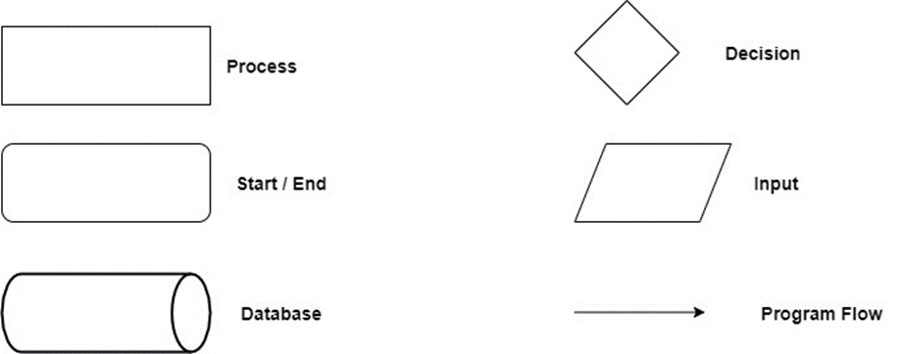

**Login:**

1. **Logout:**

1. **Main data flowchart for users:**

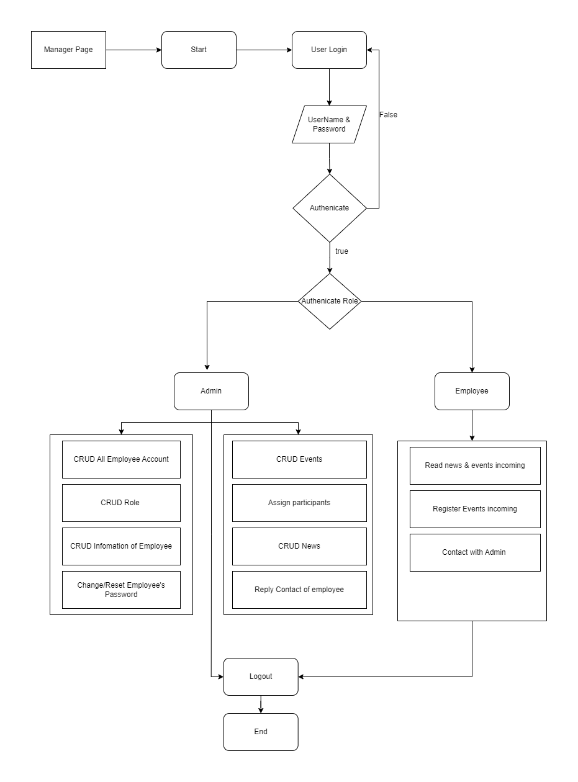

1. **Use Case Diagrams**

1. **Entity – Relationship Diagrams**

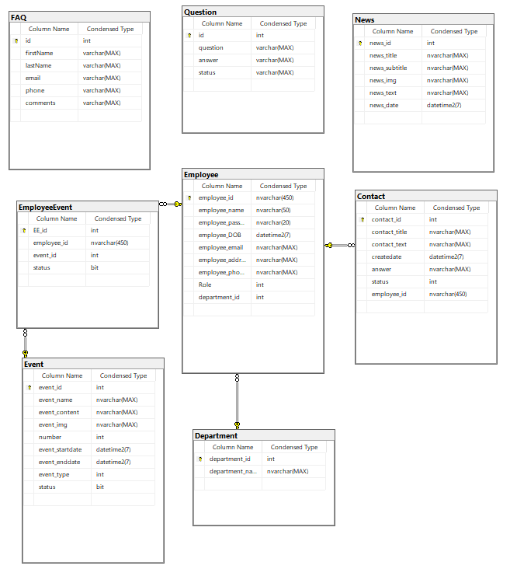

# Task Sheet Review 2

| **Project Ref. No.:**  **eP/Vehicle-Insurance- Management/04** | | **Project Title:** | **Activity Plan**  **Prepared**  **By:** | **Date of Preparation of Activity Plan:** | | | |
| --- | --- | --- | --- | --- | --- | --- | --- |
| **Sr. No.** | **Task** | **Actual Start**  **Date** | **Actual**  **Days** | **Team**  **Mate**  **Names** | **Status** |
| 1 | Architecture & design of the project | Employee Management | All Members | 18/2/2023 | 1 | All members | Completed |
| 2 | Algorithms – data flowchart | 18/2/2023 | 1 | All members | Completed |
| 3 | Use case diagrams | 18/2/2023 | 1 | All members | Completed |
| 4 | Entity- Relationship diagrams | 18/2/2023 | 1 | All members | Completed |
| **Date: 02/18/2022** | | | | | | | |
| **Signature of Instructor**    **Mr. Tran Phuoc Sinh** | | | | **Signature of Team Leader**    **Phan Thanh Phuong** | | | |

REVIEW 3

**I. Site Map**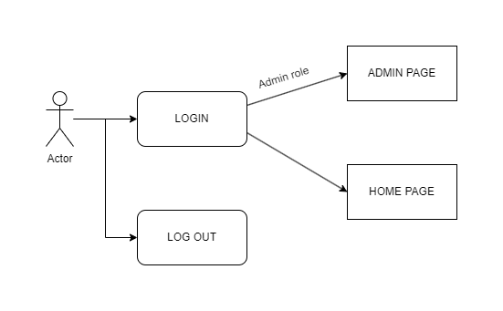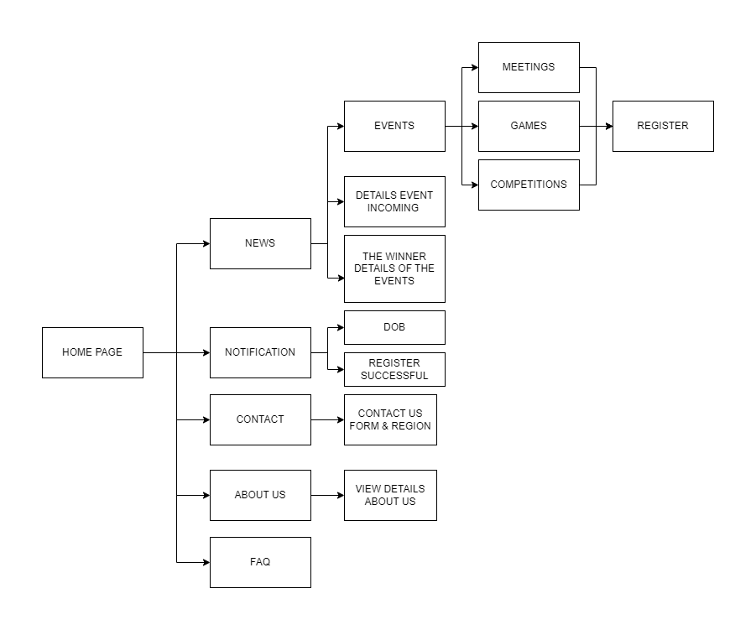

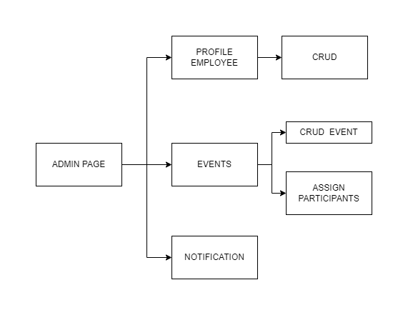

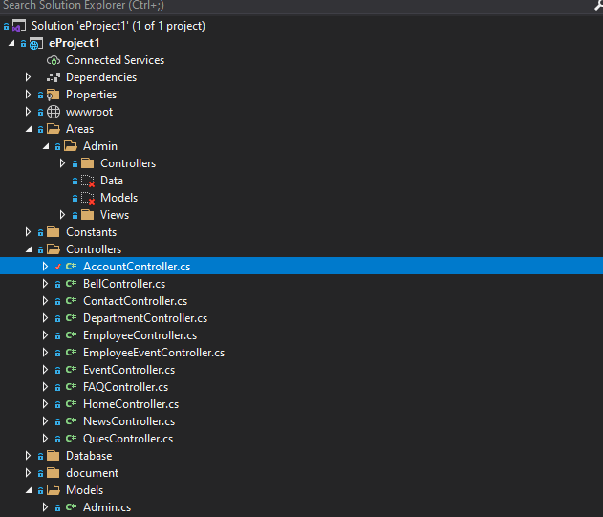

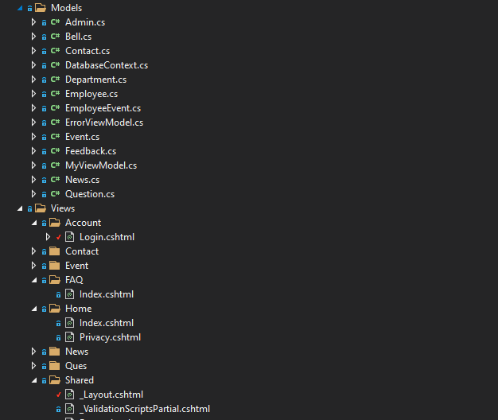

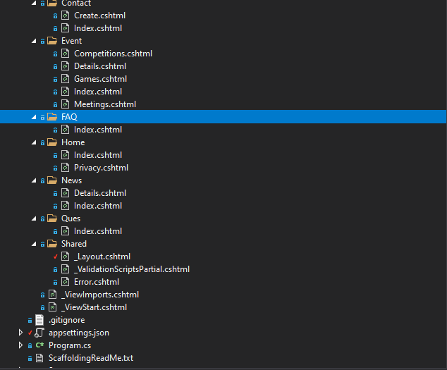

**II.GUI**

**1.User Site Map**

**a. HomePage**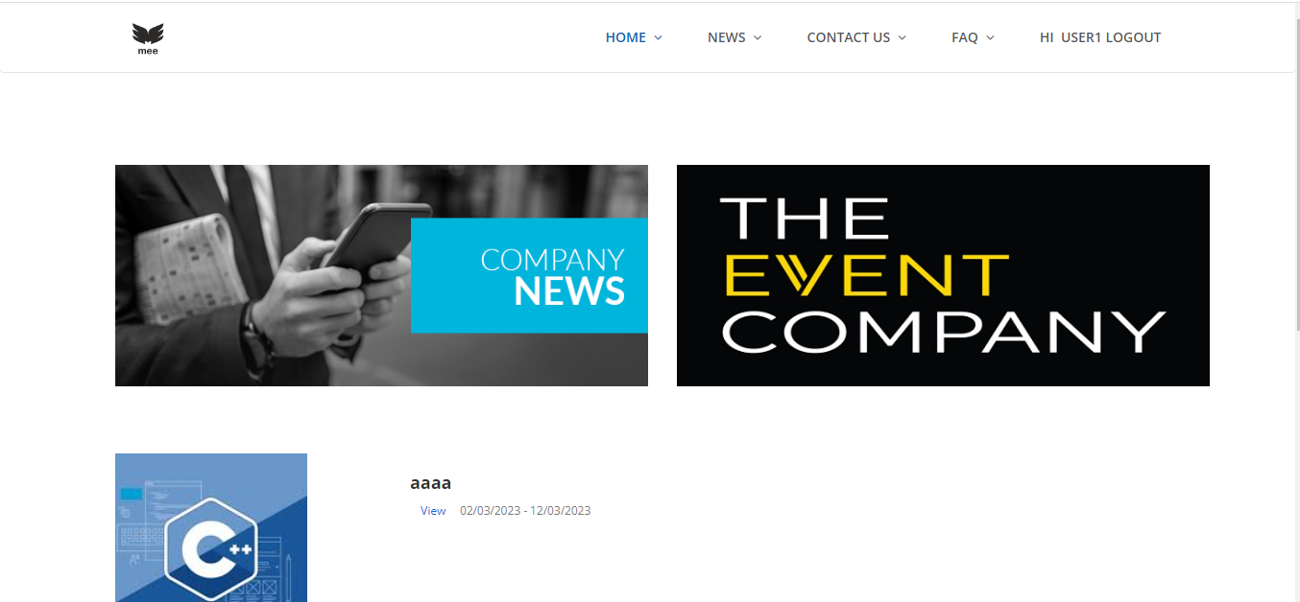

| Description | HomePage |
| --- | --- |
| Connect From | N/A |
| Connect To | News Page, Login Page, Contact Us Page, FAQ Page |
| Validation | N/A |
| Initial Values | N/A |
| Events | Navigate the website by clicking on News. |

**b. Login**

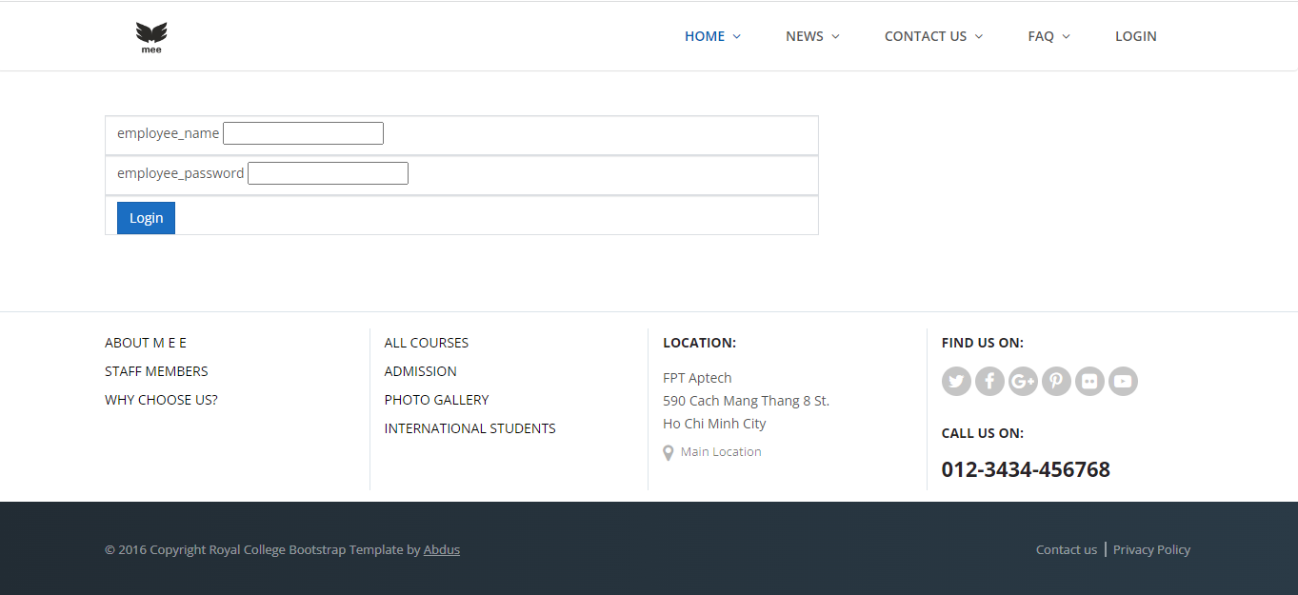

| Description | LoginPage |
| --- | --- |
| Connect From | N/A |
| Connect To | Admin Page & Home Page |
| Validation | N/A |
| Initial Values | N/A |
| Events | Login Admin with Admin Account and Home Page with User Account |

**c. Event Information**

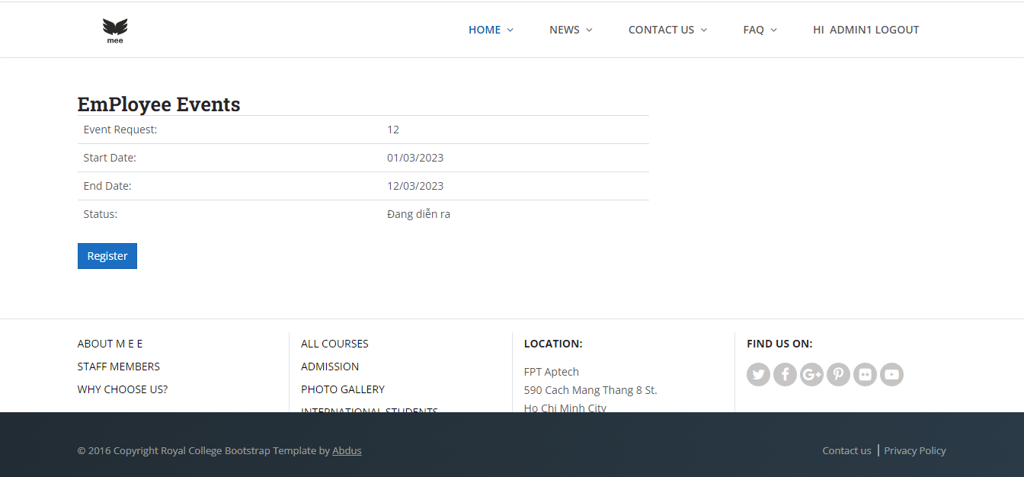

| Description | News Pages |
| --- | --- |
| Connect From | N/A |
| Connect To | N/A |
| Validation | N/A |
| Initial Values | N/A |
| Events | Send request to admin which want to enjoy this event |

**2. Admin Site Map**

**a. Home**

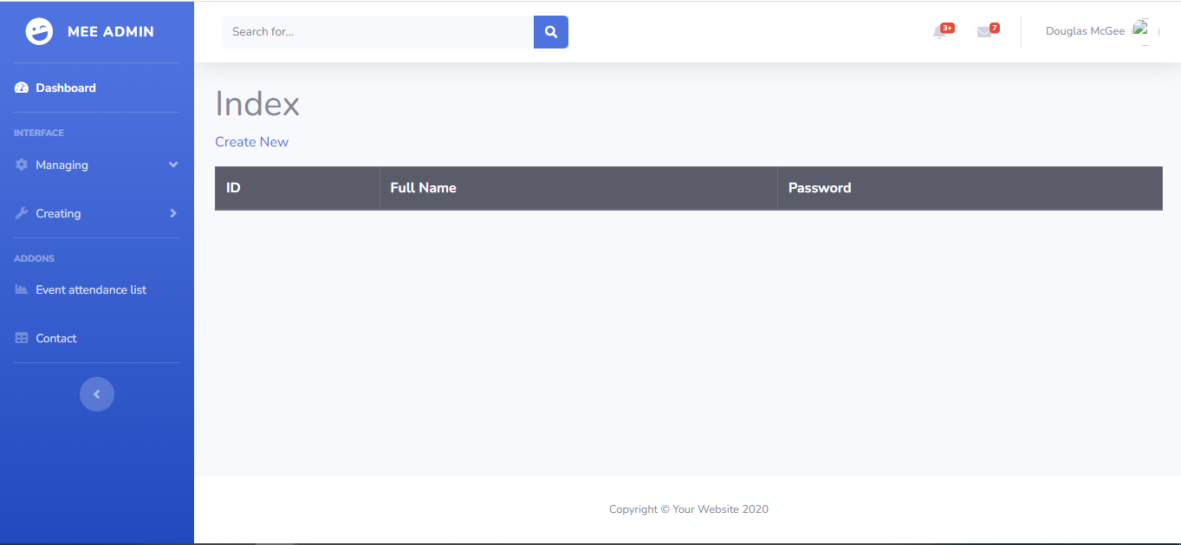

| Description | AdminPage |
| --- | --- |
| Connect From | N/A |
| Connect To | Managing Page, Creating Page, Event attendance list & Contact |
| Validation | N/A |
| Initial Values | N/A |
| Events | CRUD Account, Events and News |

**b. Employee List**

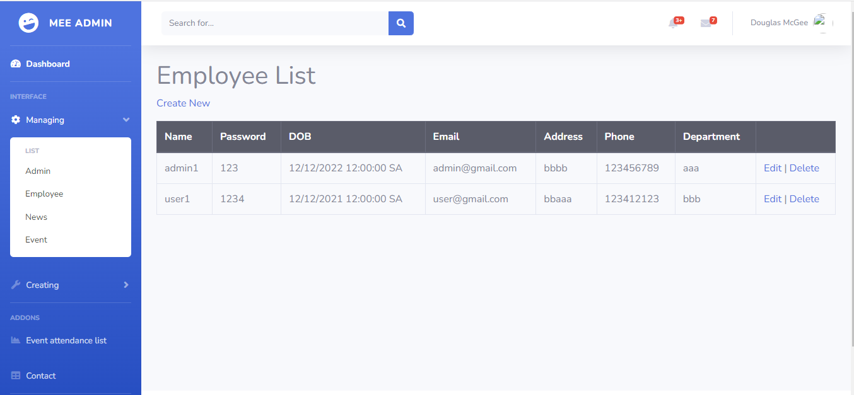

| Description | AdminPage |
| --- | --- |
| Connect From | N/A |
| Connect To | N/A |
| Validation | N/A |
| Initial Values | N/A |
| Events | List Employee and Admin was created |

**c. News List**

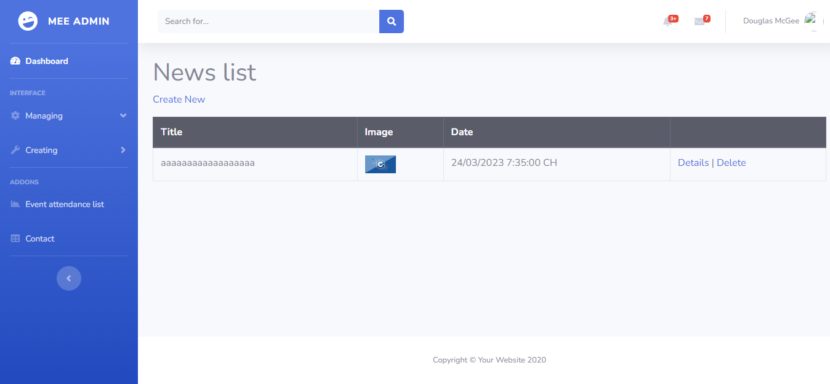

| Description | NewsListPage |
| --- | --- |
| Connect From | N/A |
| Connect To | N/A |
| Validation | N/A |
| Initial Values | N/A |
| Events | List News was created and admin can update delete this news |

**d, Event List**

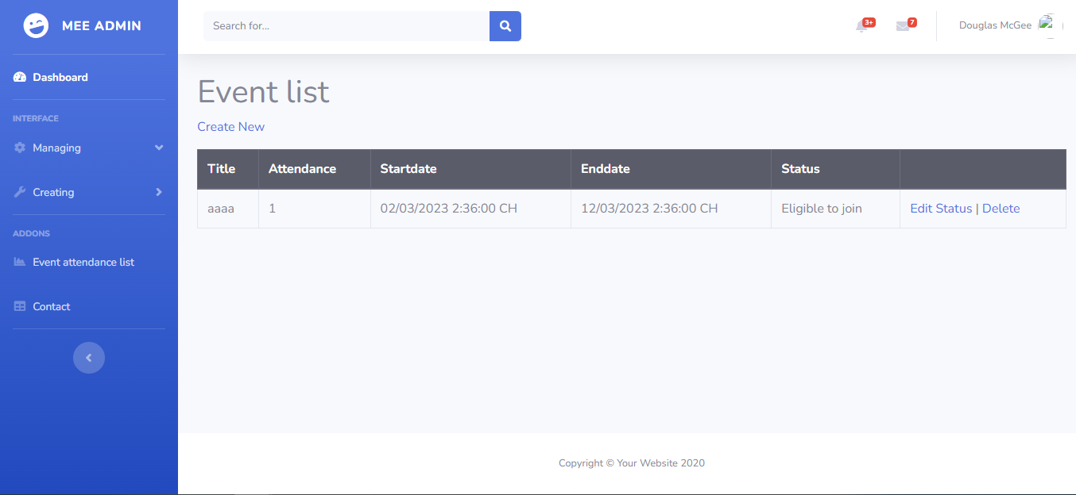

| Description | Events List Page |
| --- | --- |
| Connect From | N/A |
| Connect To | N/A |
| Validation | N/A |
| Initial Values | N/A |
| Events | List Events was created and admin can update delete this Events |

* 1. **Employee Create**

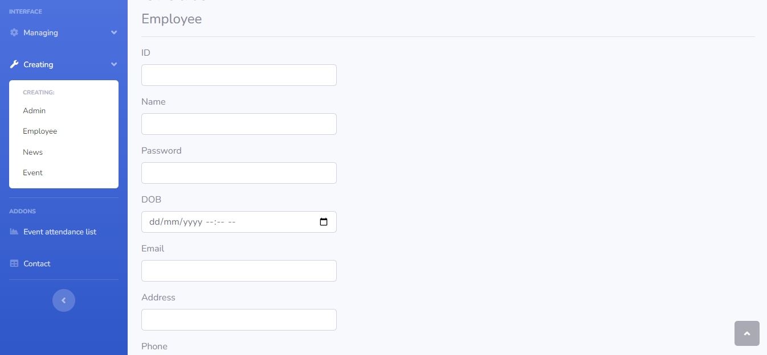

| Description | Employee Create |
| --- | --- |
| Connect From | N/A |
| Connect To | N/A |
| Validation | N/A |
| Initial Values | N/A |
| Events | Create new Employee Account |

* 1. **News Create**

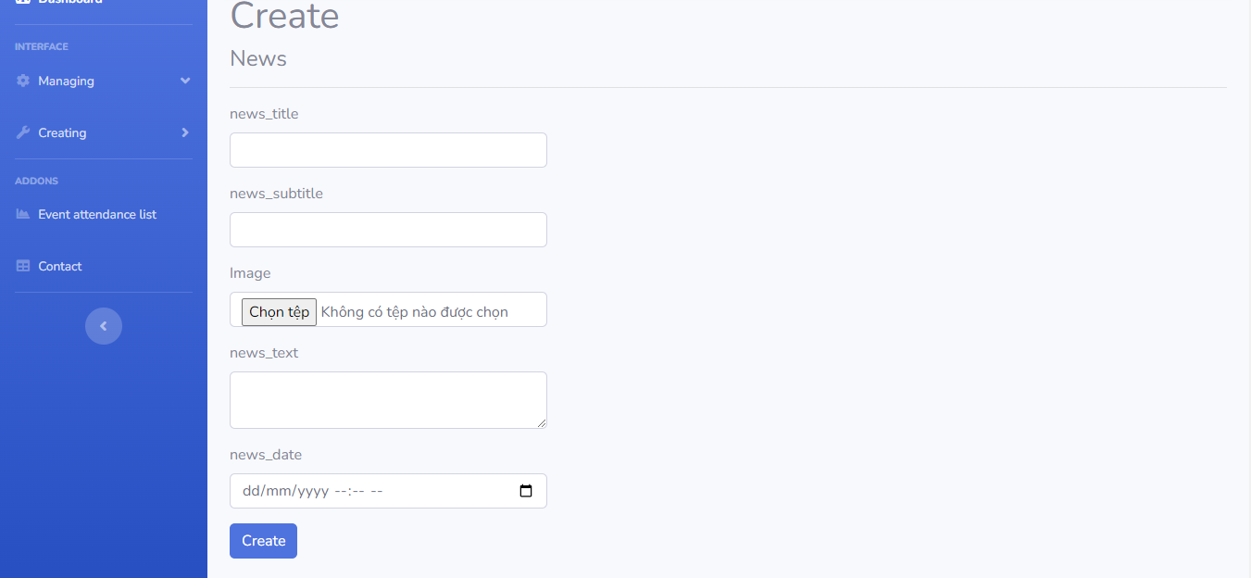

| Description | News Create |
| --- | --- |
| Connect From | N/A |
| Connect To | N/A |
| Validation | N/A |
| Initial Values | N/A |
| Events | Create new News |

* 1. **Event attendance list**

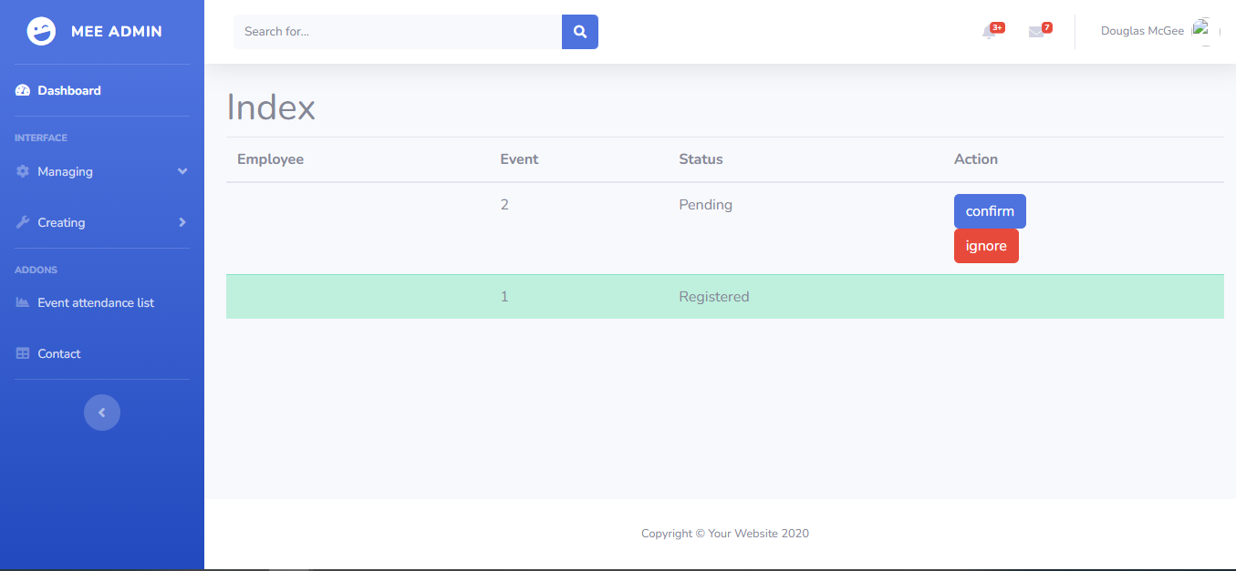

| Description | Event attendance list |
| --- | --- |
| Connect From | N/A |
| Connect To | N/A |
| Validation | N/A |
| Initial Values | N/A |
| Events | Accept request of Employee who send |

# Task Sheet Review 3

| **Project Ref. No.:**  **eP/Vehicle-Insurance- Management/04** | | **Project Title:** | **Activity Plan**  **Prepared**  **By:** | **Date of Preparation of Activity Plan:** | | | |
| --- | --- | --- | --- | --- | --- | --- | --- |
| **Sr. No.** | **Task** | **Actual Start**  **Date** | **Actual**  **Days** | **Team**  **Mate**  **Names** | **Status** |
| 1 | Site Map | Employee Management | All Members | 03/3/2023 | 1 | Nguyen Tam Hieu | Completed |
| 2 | HomePage GUI | 03/3/2023 | 1 | Nguyen Duc Anh | Completed |
| 3 | Login GUI | 03/3/2023 | 1 | Vu Lam Minh Tuan | Completed |
| 4 | Event Infomation | 03/3/2023 | 1 | Tran Le Thien Phuc | Completed |
| 5 | Home Admin | 03/3/2023 | 1 | Nguyen Tam Hieu | Completed |
| 6 | Employee List | 03/3/2023 | 1 | Tran Le Thien Phuc | Completed |
| 7 | News List | 03/3/2023 | 1 | Vu Le Minh Tuan | Completed |
| 8 | Event List | 03/3/2023 | 1 | Nguyen Duc Anh | Completed |
| 9 | Employee Create | 03/3/2023 | 1 | Tran Le Thien Phuc | Completed |
| 10 | News Create | 03/3/2023 | 1 | Nguyen Tam Hieu | Completed |
| 11 | Events Create | 03/3/2023 | 1 | Nguyen Duc Anh | Completed |
| 12 | Event attendance | 03/3/2023 | 1 | Nguyen Tam Hieu | Completed |
| **Date: 03/02/2023** | | | | | | | |
| **Signature of Instructor**    **Mr. Tran Phuoc Sinh** | | | | **Signature of Team Leader**    **Phan Thanh Phuong** | | | |